Guidelines for Preparing Manuscripts for the Abstract Book
for the 29th Annual Conference, Osaka 2026

Taro Fukushi¹・Hanako Machidukuri²

¹ Faculty of Engineering, Fukushi University, Dr.Eng・E-mail:fukushi@fukumachi.ac.jp
^{２}Faculty of Engineering, Machidukuri University, M.Eng・E-mail:machizukuri@machi.ac.jp

From the 2021 Annual Conference onward, the membership category (Regular, Student, or Supporting Member) must be indicated in the author affiliation section.
An abstract and keywords must be provided before the main text. The abstract should be approximately 200 words in length and should use the same font size and typeface as the main text, and should be placed in this section. Up to six keywords should be provided in English, using Arial font at 10.5 points.
Since this Society has an interdisciplinary character, authors are requested to give due consideration so that their work can be easily understood and used by participants from other fields (for example, by adding a subtitle to the title). Applications for presentations, conference participation, and submission of abstract manuscripts shall be made via the Society’s website.

Keywords: Japanese Association toward Caring Society for All, Submit a Paper

- Purpose of the Abstract Book and Considerations

The Abstract Book is prepared in order to accurately communicate the content of each presenter’s report to the audience. Abstracts of both Special Session Papers and General Papers shall be published in the same format. The abstracts are also intended to be used as reference materials by other researchers over the long term.
In addition, this Society places great importance on information accessibility. Abstract manuscripts shall therefore be prepared with due consideration of the following two points:
(1) Compatibility with screen-reading software
Manuscripts must be prepared without using text boxes in the main text. Authors must also submit both the abstract manuscript and its text file.
(2) Consideration for diversity in color vision
Authors should take into account the diversity of color vision among readers and give due consideration to visibility and readability, including issues such as color reproduction in printing, printing effects, and color display on screens.
Furthermore, submission of a PDF generated from an accessibility-checked Word document is strongly recommended. For details on how to create such a file, please refer to the appendix at the end of these guidelines.

2. Structure and Page Length

2.1 Structure and Text Styles
Each paper shall be organized in the following order: Title, Subtitle (if necessary), Author name(s), Abstract, Keywords, Main text, References, and so forth.
The format of each item shall be as follows:
Title
Arial, 12-point, centered
Subtitle (if necessary)
Arial, 12-point, centered
Author name(s) (including co-authors)
Times New Roman, 10.5-point or larger, right-aligned
Affiliation(s) of author(s) (including co-authors)
Times New Roman, 10.5-point or larger, centered
2.2 Page Length
The length of each paper shall be as follows, per presentation: General Papers shall be either 2 pages or 4 pages, and Special Session Papers shall be 6 pages at the time of abstract manuscript submission.
For Special Session Papers, comments and evaluations shall be provided based on the submitted manuscript, and the results of the review will be returned to the authors. However, submission of a revised manuscript based on these comments is not required.

3. Format, Fonts, Colors, and Layout

3.1 Format
Manuscripts shall be prepared in A4 size. The main text shall be set in Times New Roman at approximately 10.5 points. The standard layout shall be two columns, each column consisting of approximately 40 lines with 20 characters per line, with a two-character space between columns. The margins shall be 30 mm at the top and 25 mm at the bottom, left, and right.
In principle, authors should use the provided file as the template. However, if the exact format cannot be reproduced due to limitations of the word processor’s printing function, authors should make the layout as close as possible in terms of font size, number of characters per line, and number of lines.
Manuscripts must not be created using text boxes, as they are not compatible with screen readers. This restriction does not apply to figures, tables, or photographs.
3.2 Fonts to Be Used
For English text, acceptable fonts are: Arial, Century, and Times New Roman.
3.3 Colors
The color of the text shall be black. No particular restrictions are imposed on the use of colors other than for text. However, authors should take into account the diversity of color vision among readers and give due consideration to color reproduction in printing, printing effects, and color display on screens.

4. Styles and Sizes of Text in Figures and Tables
Figures, tables, and photographs shall be placed at appropriate positions in the manuscript and shall be given consecutive numbers and titles in accordance with the following rules. Titles should, in principle, be set in Gothic (sans-serif) font at 10.5 points, and should be written directly in the main text without using text boxes.
Figures shall be numbered as “Figure 1,” “Figure 2,” etc., and placed centered below the figure.
Tables shall be numbered as “Table 1,” “Table 2,” etc., and placed at the upper left of the table.
Photographs shall be numbered as “Photo 1,” “Photo 2,” etc., and placed centered below the photograph.

Figure 1. Example of a Figure Title

Table 1. Example of a Table Title

Photo 1. Example of a Photo Title

5. Standardization of Format and Structure of the Main Text

5.1 Standardization of Format
The purpose of standardizing the format is to ensure a consistent style for the Society’s proceedings and to improve the readability of papers. In addition, since this Abstract Book is prepared on the assumption that it will be used by readers employing various assistive devices, authors are requested to cooperate in maintaining a unified format in order to facilitate such use.
5.2 Structure of the Main Text
The main text shall be composed of chapters such as Objectives, Methods, Results (Analysis), Discussion, and Conclusions (Future Work), as well as sections and subsections that further subdivide and explain the content of these chapters. The chapters, sections, and subsections shall be written in the following style. This style includes information necessary for visually impaired readers using screen-reading software to identify their current location in the text and to move to desired sections.
〇. Arial Title
Arial font, same font size as the main text, left-aligned, with one blank line above and below the title
○.1 Section Title
Arial font, same font size as the main text, left-aligned
○.1.1 Subsection Title
Arial font, same font size as the main text, left-aligned
When the content is organized using item numbers rather than these classifications, authors should use numbers in parentheses such as “(1)” or letters such as “a, b, c,” so that each item can be easily identified.
A standard chapter structure for papers is shown below:
(1) Research Objectives, or “Introduction”
Briefly summarize the social context related to the research and trends in surrounding fields. This also helps to indicate the positioning of the research for readers from other disciplines.
(2) Research (Survey) Methods
Describe the survey or experimental subjects, the content and period of implementation, specific procedures, an outline of the equipment, experimental methods, and an overview of the participants.
(3) Research (Survey) Results
Describe the data obtained and the results of tabulation and analysis.
(4) Discussion
Based on the results, describe the authors’ interpretations and considerations.
(5) Conclusion, or “Future Work,” “Summary,” etc.
Summarize the future direction of the research.
(6) References, etc.
List the literature that was referred to for the research methods or the study itself, or that was cited for comparison or discussion of results in the text. For cited works, clearly indicate the cited locations and page numbers. In all cases, it is recommended that the font size be set to approximately one point smaller than that of the main text (an example is provided at the end of these guidelines).

6. Submission Guidelines and Deadlines

6.1 Submission of Abstract Manuscripts
(1) Submission Format
In principle, authors shall submit both a PDF file (viewable and printable with Adobe Reader or equivalent software) and a plain text file. The PDF file shall be generated from an accessibility-checked Word document and shall be printable as intended by the author(s). The plain text file shall be prepared by removing figures and tables from the manuscript and adding brief explanations of them.
If, for unavoidable reasons, authors are unable to prepare both the PDF and the plain text file, or if the author is visually impaired, submissions in Word format will also be accepted. In such cases, authors should be aware that the manuscript may not appear exactly as intended. The file should be submitted as an email attachment to the Conference Help Desk: jais-desk@conf.bunken.co.jp
(2) PDF File Size
The file size must be 3 MB or less. If the file size exceeds 3 MB, authors should reduce the file size by, for example, lowering the resolution of embedded images (e.g., by using the “Compress Pictures” function in Microsoft Word). Authors are requested to cooperate in keeping file sizes as small as possible.
(3) No Security Settings on Submitted Files
When creating the PDF file, do not insert page numbers. In addition, no security settings or password protection shall be applied to the file.
6.2 Deadline for Submission of Abstract Manuscripts
Abstract manuscripts shall be submitted electronically via the Society’s website
(https://www.fukumachi.net/taikai/resume.html
).
The deadlines for this year are as follows. Please note that, as this may affect conference operations, replacement or revision of manuscripts after submission, as well as any extension of the deadline, will not be accepted.
<General Papers and Special Session Papers>
Registration period: March 2, 2026 – April 13, 2026
Manuscript submission period: March 2, 2026 – May 12, 2026
The maximum number of presentation applications per corresponding presenter is two (for Supporting Members, one).
6.3 Notes and Support (Reasonable Accommodation)
(1) Changes to Manuscript Content after Application
Changes to presentation information after submission of the presentation application—such as changes to the title or deletion of co-authors—are not permitted.
(2) Co-authors
Not only the presenter but also all co-authors must be members of the Society. In principle, non-members must complete the membership registration process by the time the abstract manuscript is submitted.
(3) Support (Reasonable Accommodation)
If an author requires any form of support due to their physical or mental characteristics and makes a request in advance, the Society will respond in good faith as follows:
<Support when confirmation is required at the time of abstract submission>
The staff member in charge of accepting the submission (e.g., the Paper Committee) will confirm together with the author the name(s), co-author(s), affiliation(s), contact information, and title.
With the author’s consent, information will be shared with co-authors to enable smooth and coordinated responses to accommodation needs.
However, the following types of support will not be provided, as they may affect conference operations:
Cases that fall outside the scope of the Society’s essential operational duties;
Cases that involve changes to essential aspects or undermine the objectives of the Society;
Cases that exceed the provision of equal opportunities compared to others and impair fairness;
Cases in which the human, financial, or other burdens would be excessive.

7. Copyright Policy

The handling of copyright for the Abstract Book of this Conference shall be defined as follows:
(1) The author(s) shall entrust the Japanese Association for an Inclusive Society with the right to use the copyright of the published papers and records of questions and discussions.
(2) There shall be no particular restrictions on authors using their own papers or records of questions and discussions for their own purposes.
(3) The editorial and publishing rights shall belong to the Japanese Association for an Inclusive Society.

8. Inquiries

All questions and inquiries should be made by e-mail.

[Inquiries regarding presentation registration and manuscript submission]
Conference Help Desk, Japanese Association for an Inclusive Society
E-mail: jais-desk@conf.bunken.co.jp
[Other inquiries regarding the Conference]
Secretariat of the 29th Annual Conference (Osaka) Organizing Committee
E-mail: taikai2026office@fukumachi.net

References
- Kawauchi, Y.: Universal Design: Questioning Barrier-Free, Gakugei Publishing, 2001.
- Japanese Association for an Inclusive Society: Japanese Association for an Inclusive Society Website, http://fukumachi.net/, 2006.7.
- Fukushi, T., Machizukuri, H.: Instructions to Submit a Paper, Journal of Japanese Association for an Inclusive Society, Vol. 15.

Appendix: Creating Accessible PDFs (Example Using Microsoft Word)
Submission of a PDF generated from an accessibility-checked Word document is a measure intended to ensure compatibility with screen-reading software as a standard. An example of how to create such a file is shown below. Please also confirm that the PDF file is printed as intended by the author(s).
(1) PDF Generated from an Accessibility-Checked Word Document
A “PDF generated from an accessibility-checked Word document” refers to a PDF file that is compatible with screen readers by default when using Adobe Acrobat. The following web pages provide useful guidance on how to create such files:
“Create Accessible Word Documents”
(http://tinyurl.com/y69y9rhc)
“Create Accessible PDF Files – Office Support”
(http://tinyurl.com/y4mape24)
“Create and Verify Accessible PDFs, Acrobat Pro”
(https://helpx.adobe.com/jp/acrobat/using/create-verify-pdf-accessibility.html)
(2) Accessibility Check
Although the exact procedure may vary depending on the version of Word, in principle, by selecting File > Info > Prepare for Sharing > Check Accessibility (as shown in Figure 2) and correcting any errors as much as possible, it is possible to create a PDF generated from an accessibility-checked Word document (i.e., a file that can be displayed, printed, and read aloud using Adobe Reader or equivalent software).
(3) How to Add Tags to Figures and Tables
In Word documents, figures and tables can be embedded with “tags” that describe what each figure or table represents, so that this information can be read aloud from the PDF data. This makes it possible for the text to be read in an appropriate order even after conversion to PDF.
When creating a PDF from a Word document, by checking the option “Create tagged PDF and enable accessibility and reflow”, a PDF can be generated that contains information on the document structure (reading order) and alternative text (descriptions of the contents of figures and tables).
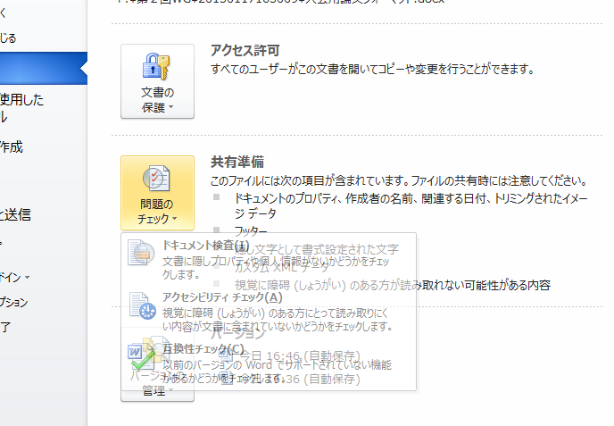
Figure 2. Accessibility Check Screen

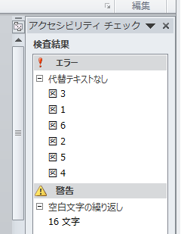
Figure 3.Example of Accessibility Check Results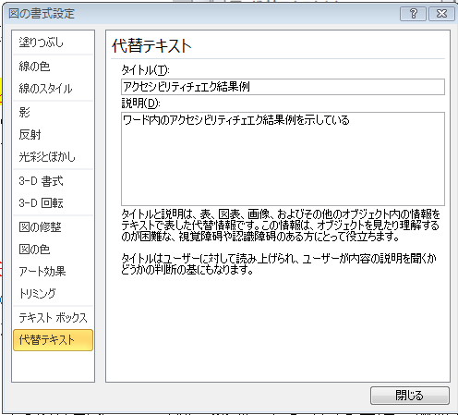
Figure 4. Screen for Entering Alternative Text for Figures and Tables

